Day 3: (task 3)
Writing Basic SELECT Queries:
1. Select data from users: (select all data from users table)
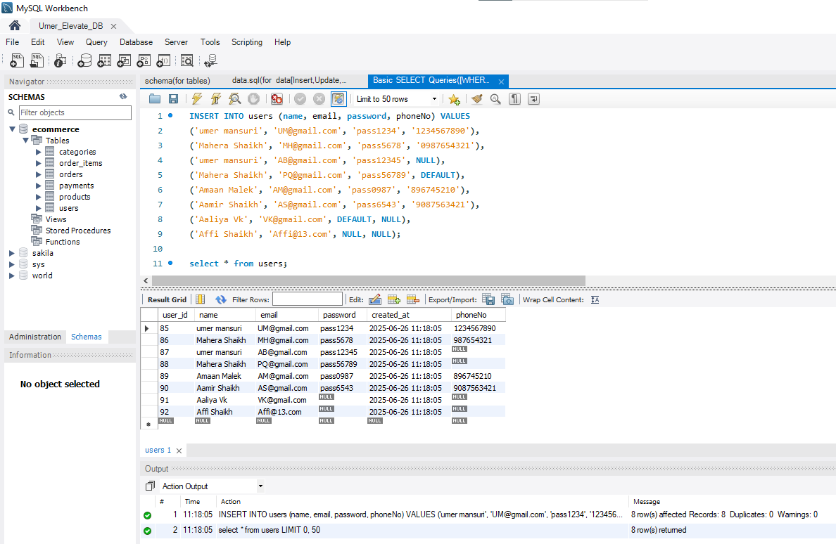
2. Select data from some specific column in the table:
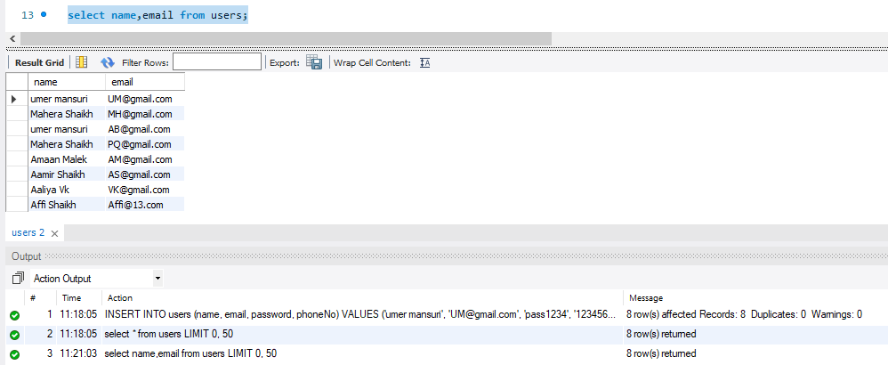

3. Select data from two column in the table and selected user_id :
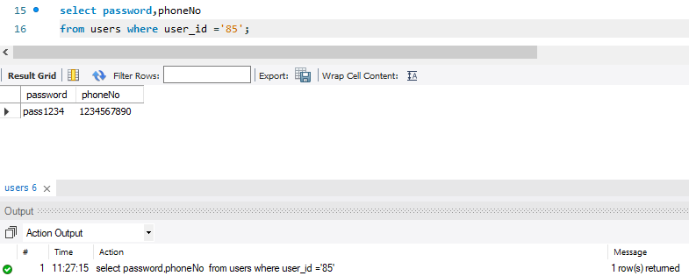
4. Arranging the database in descending order: (only for name column)
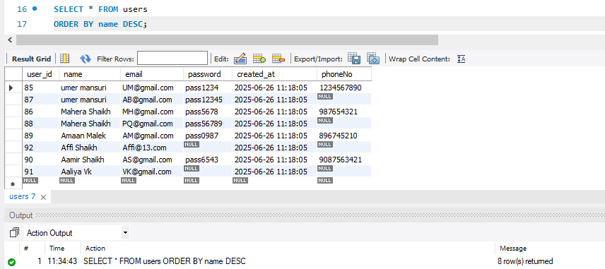
5. Arranging the database in ascending order: (Use for email, password column)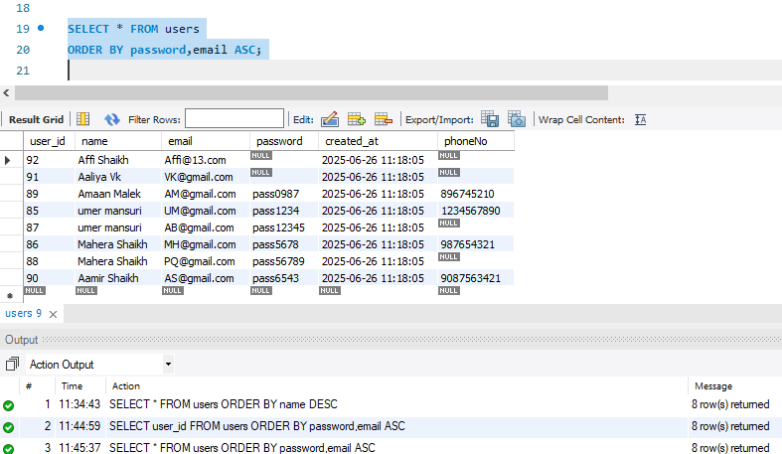

6. To fetch records of users where User_id is between 91 and 96: (use with where, between, and)
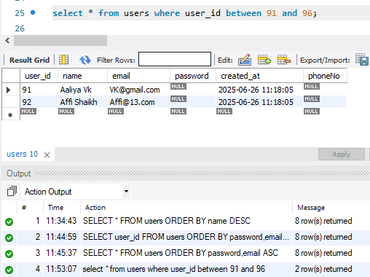
7. To fetch records of users where Name starts with the letter A.(use with LIKE operator)
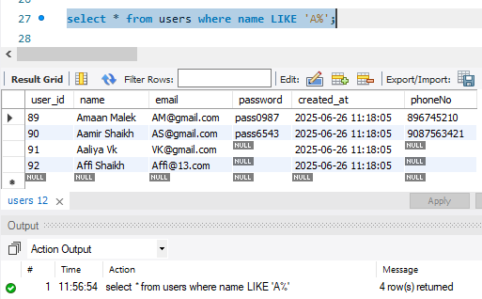

7. Select the data from user table set limit from 92:
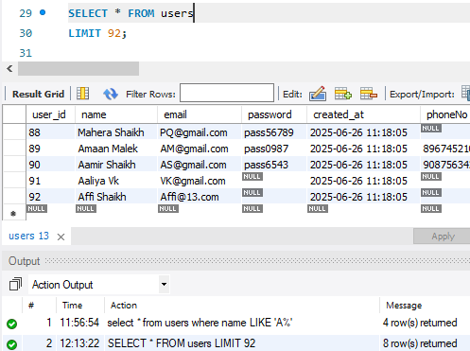
8. To fetch records of products where price is between 500 and 5000:
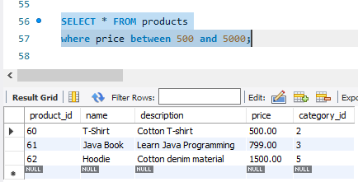
9. To fetch records of orders where check the status and user_id =2:
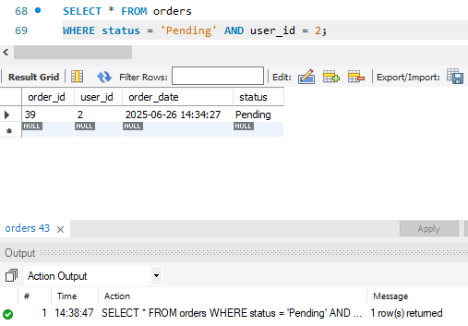

10. To fetch records of products where price is less than 500:
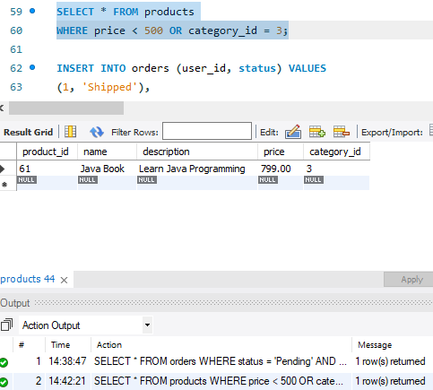
11. We will fetch all data from the table products and sort the result in descending order according to the column price.
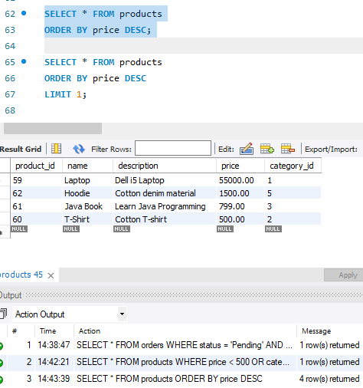

12. We will use the SELECT LIMIT clause to display only 2 results.
ORDER BY price DESC
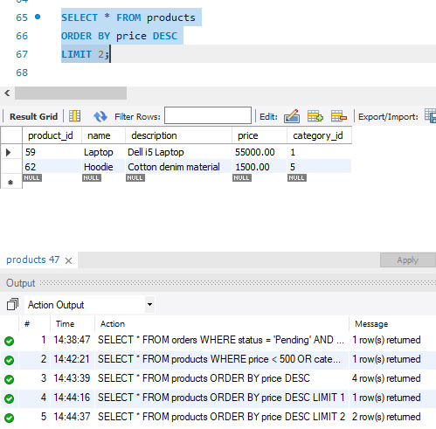
13. To fetch records of orders where display the unique id.
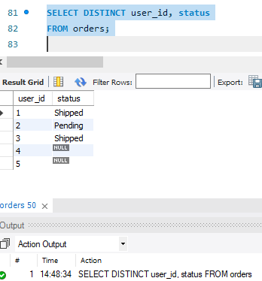
14. Only display the unique name:
